Real Numbers — Mind Map
Chapter ID: MT10CBSE-MATH-RN | Board Syllabus Only

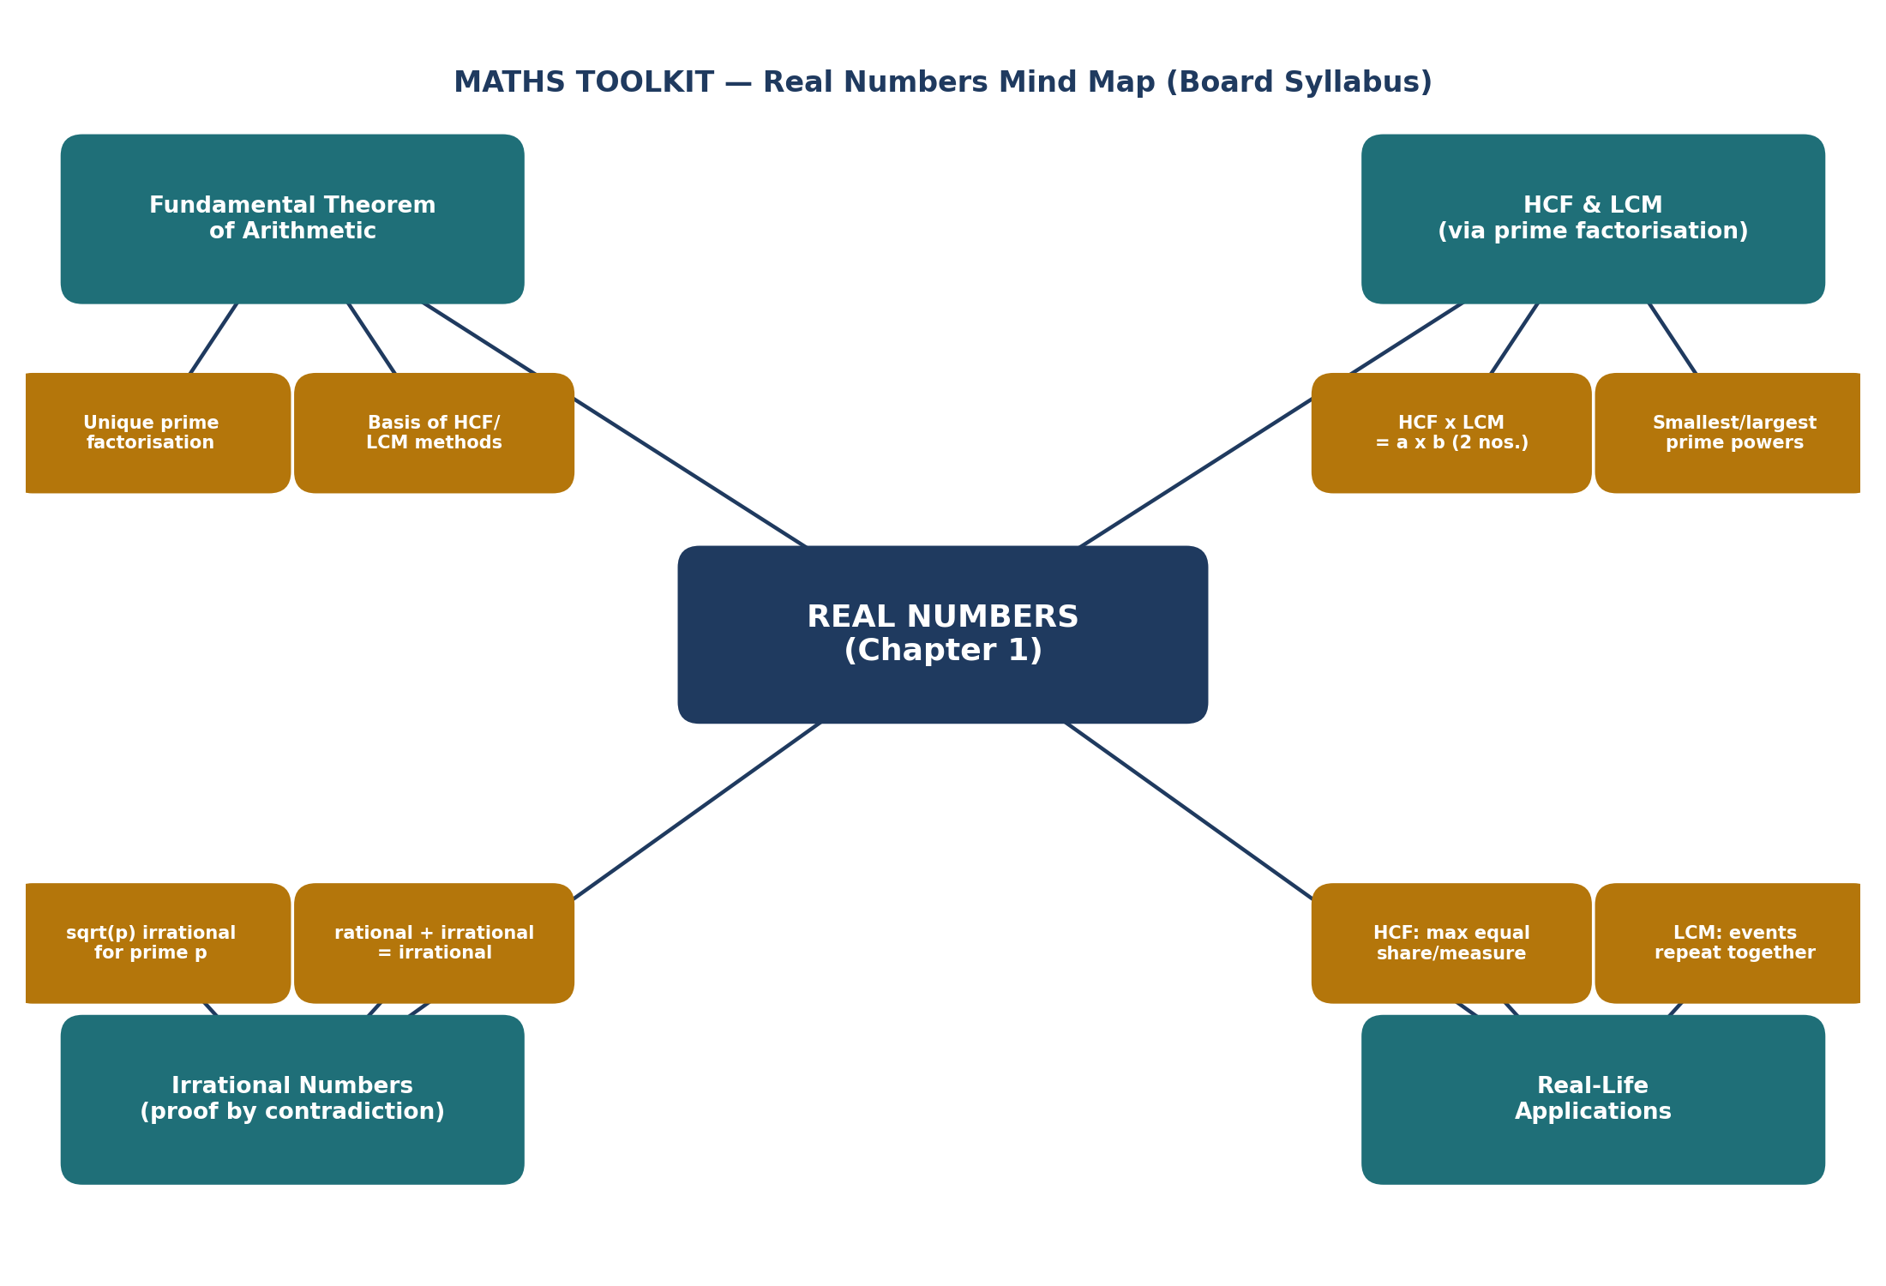

Note: this map covers Board-syllabus concepts only. Beyond-syllabus topics (Euclid’s Division Lemma/Algorithm, decimal-expansion theorems) and the Competition Window bonus formulas are deliberately left off this map — see the Formula & Result Book, Part B, for those.

